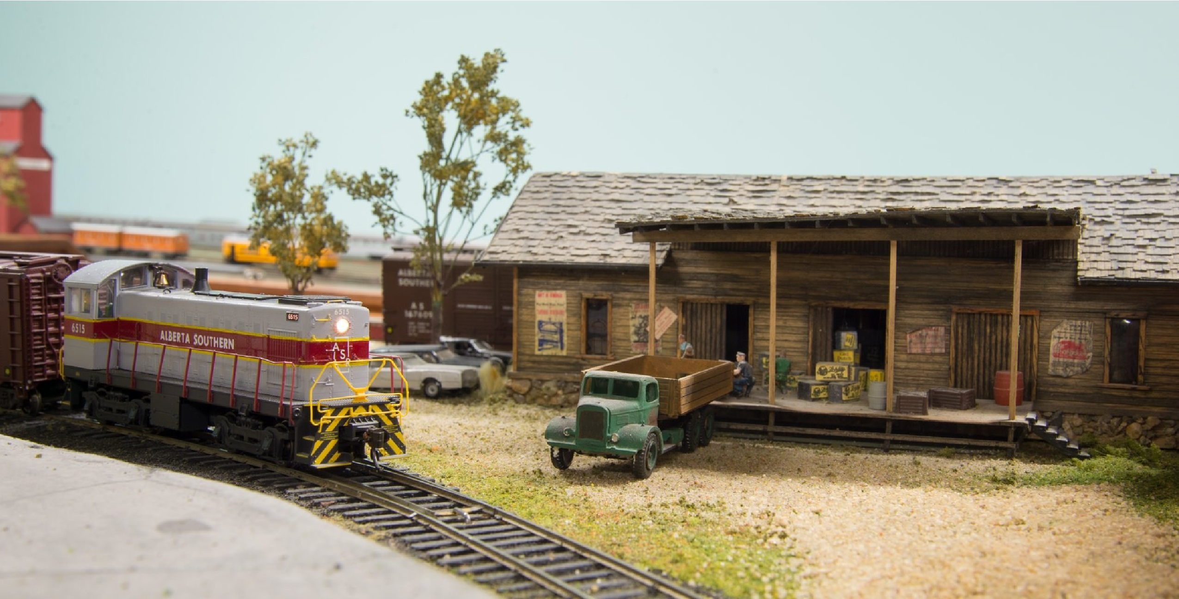

The Southern Alberta Model Railway Club

presents their

**Spring Open House**

featuring the:

**ALBERTA SOUTHERN RAILWAY**

**22**

**-**

**23**

**March**

**2025 1100**

**-**

**1600**

**Hours**

**Gyro Park 1420**

**-**

**10**

**A Avenue South**

Everyone Welcome!

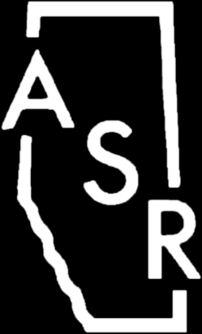

Free admission, but donations gratefully accepted.